Algebra 2 (Honors)

Section 1.3: Scatter Plots and Correlation
Date: ________________________________
Objectives:
- Students will be able to graph a scatter plot and identify the data correlation.
- Students will use a graphing calculator to find the correlation coefficient and to make predictions using the line of best fit.

Main Idea | Notes
Do Now:  Vocabulary: Scatter Plots  Vocabulary: Positive Correlation | Write down as many examples of real world situations that describe a relationship between two variables. What type of trends, if any, might you see?  (Example to get you started: Your age and height. There is an increasing trend. As your age increase, your height increases)  Examples: Trend:  1. ______________________________ _________________________________  2. ______________________________ _________________________________  3. ______________________________ _________________________________  4. ______________________________ _________________________________  5. ______________________________ _________________________________  A scatter plot is ____________________________________________________________________________  ______________________________________________________________________________________________  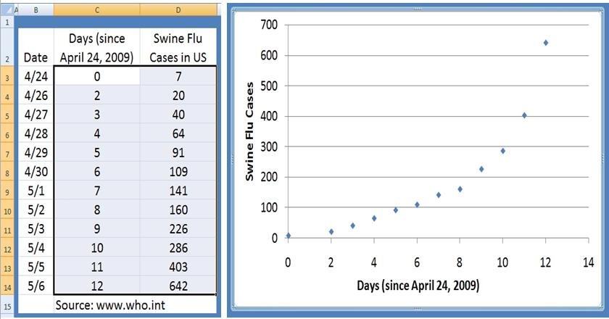  Positive Correlation:  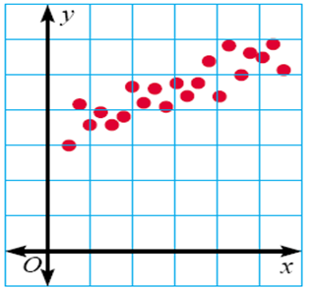  Example:
Vocabulary: Negative Correlation  Vocabulary: No Correlation | Negative Correlation:  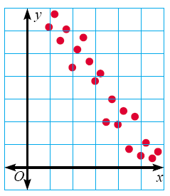  Example:  No Correlation:  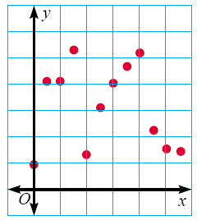  Example:
Example 1: Identifying Linear Relationships | Which scatterplots below show a linear trend?  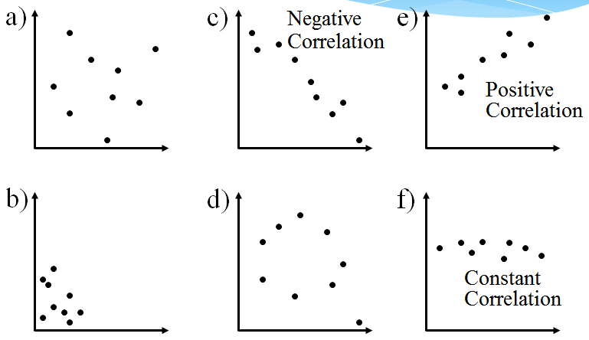
Vocabulary: Outlier | Outlier:  Example:  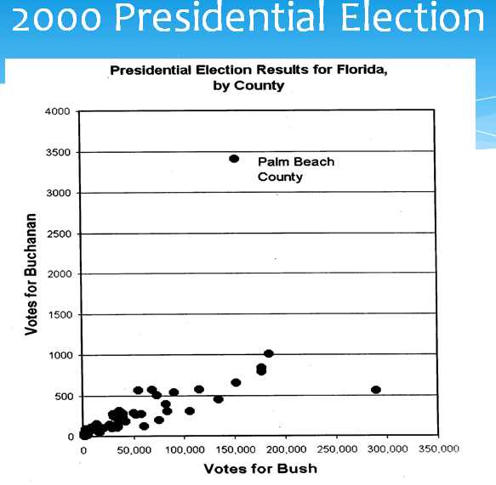
Vocabulary:  Line of Best Fit | The line of best fit is ______________________________________________________________________  _____________________________________________________________________________________________.  It may go through _________________________________________________________________________  _____________________________________________________________________________________________.  Try to have the same amount of points _________________________________________________  ______________________________________________________________________________________________.
Example 2:  Making a Scatter Plot | Plot the data on homework time and TV time on the graph  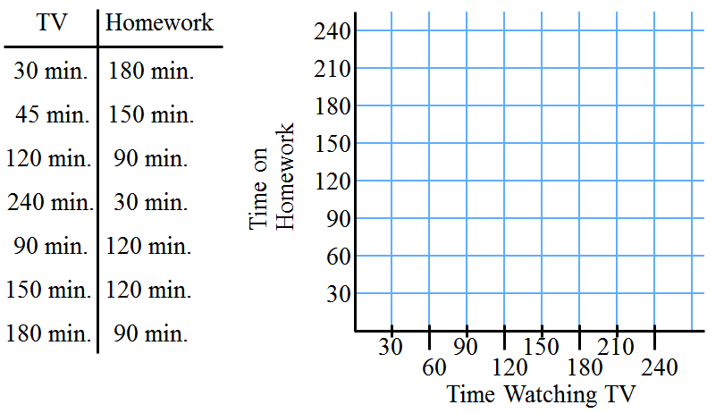  Now draw the line of best fit and describe any trends.
Vocabulary:  Correlation Coefficient | A correlation coefficient measures ______________________________________________________  ______________________________________________________________________________________________.  It is called _____________.  It describes how close the points in a scatter plot cluster around the  __________________________________________________________________.
Vocabulary: Range of Values for the Correlation Coefficient  Vocabulary: Range of Values for the Correlation Coefficient (Continued) | 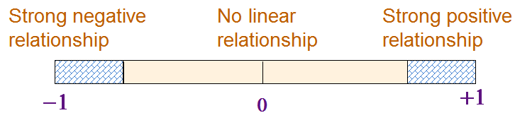  When all the points fit on the line, r = _____________ or r = _____________.  When the points are random and no line can be considered, r = __________________.  The closer this number is to 1 or -1, the closer the points are to the  ___________________________________________________________________.
Examples of Different r Values | 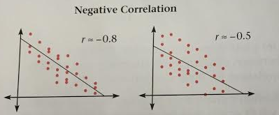  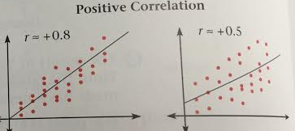
Example 3: Write the Value of the Correlation Coefficient  Vocabulary: Steps for Finding Solutions using Graphing Calculator | r = . _____ ______ r = . _____ ______  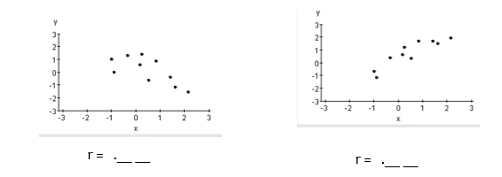  - Enter the data  - Graph a scatter plot of the data  - Find the equation of the graph  - Graph the regression line on a graph with the scatter plot
Example 4: Scatter Plots and Graphing Calculators | 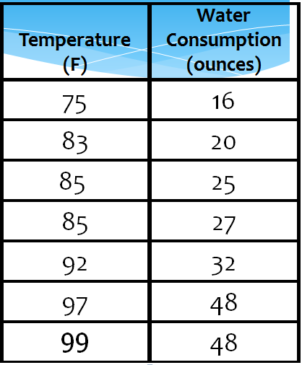  For seven random summer days, a person recorded the temperature and their water consumption.  That person wants to plan an outdoor party. Predict the amount of water a person would drink when the temperature is $95℉$.
Vocabulary: Steps to graphing a Scatter Plot and the Line of Regression on a Graphing Calculator  Vocabulary: Steps to graphing a Scatter Plot and the Line of Regression on a Graphing Calculator (Continued)  Example 4 (Continued): Scatter Plots and Graphing Calculators | Steps:  - Enter the Data into Lists:  *Press STAT  *Under EDIT, Select 1:Edit  *Enter x-values (input) into L₁  *Enter y-values (output) into L₂  2. Set up the Scatter Plot  *Press 2nd Y = (STAT PLOTS)  *Select 1: Plot 1 and hit Enter  *Move the curser to On and hit Enter  *Move the cursor to Type and select the first graph under Type.  *Under Xlist Enter L₁  *Under Ylist Enter L₂  *Under Mark: select any of these.  3. To View Scatter Plot  *To plot the points, press ZOOM and select 9: ZoomStat  4. Finding the regression line:  *Press STAT  *Press CALC  *Select 4: LinReg (ax + b)  *Press 2nd 1 (For List 1)  *Press the Comma key  *Press 2nd 2 (For List 2)  *Press Enter  What is the equation of the regression line?  Graph the line of regression in your graphing calculator.  Predict the amount of water a person would drink when the temperature is $95℉$
Example 5: Making Predictions Using a Line of Best Fit | 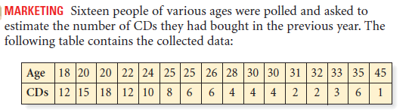  Predict the number of CDs that was purchased by a person who is 27 years old.
Homework:

